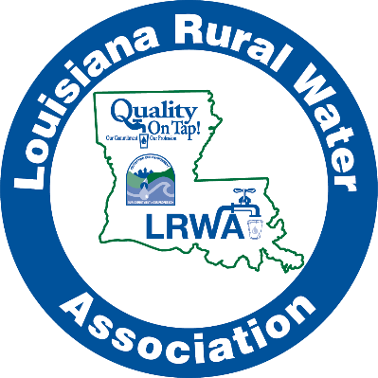
Louisiana Rural
Water Association
Water Taste Test
Entry Form

Utility/System Name
Contact Person
Contact Phone No. | ( )
Contact email address
Water Source
(Ground or Surface)
Number of Connections
Year system established

Taste Test Rules

- System must be a member of LRWA
- Collect water in a quart size glass container (be sure to package water carefully)
- Please do not fill container to top
- DO NOT “chill” water
- Label the container with your system name, contact person & phone number.
Water must be received by Monday, April 29th, 2024, before 3pm and can be brought or mailed to LRWA, 1325 3rd Avenue, Kinder, La 70648

For your water to be eligible, this form must be emailed to lsonnier@lrwa.org or faxed to (337) 738-5620 before Friday, April 26th, 2024.

