<Water System Name>
____________________ Parish, Louisiana

Contingency Plan

Source Water/Wellhead Protection Contingency Plan
Providing Alternative Drinking Water Supplies

Date:

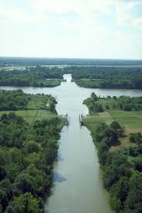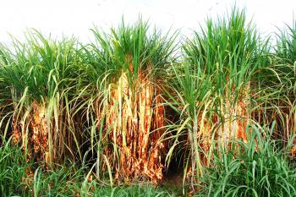
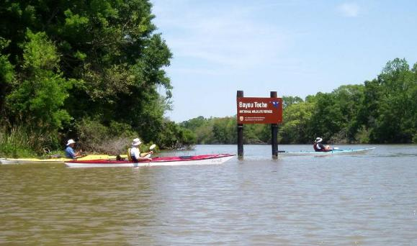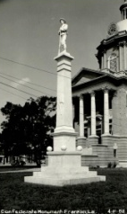

Prepared By:
Louisiana Rural Water Association
P.O. Box 180 – Kinder, LA 70648
1-800-256-2591
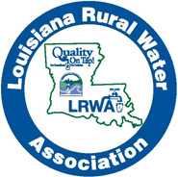

1.0 Purpose 3
2.0 Water Supply Information 4
2.1 Basic Water System Information 4
2.2 Current Sources of Supply 5
2.3 Treatment 5
2.4 Storage 5
2.5 Power Sources 5
2.6 Description of System Operation 6
2.7 Distribution System 6
3.0 Priority of Water Users 7
4.0 Short Term Replacement Alternatives 8
5.0 Inventory of Available Equipment and Materials 9
5.1 Equipment and Materials 9
5.2 Contractor/Contracted Service Providers 9
6.0 Notification Procedures 10
6.1 Incident Assessment Team 10
6.2 Emergency Contact List 10
6.3 DHH Contacts 11
6.4 Public Announcement Plan 11
Appendices 12
A. Media/Consumer Notifications: 13
B. Event and Action Log: 15
C. Sample Boil Advisory 16
D. Complete List of DHH Contacts 19
E. DHH Emergency Bulk Water Hauling Instructions 21

1.0 Purpose

The purpose of this Contingency plan is to establish, provide and keep updated certain emergency response procedures, which may become necessary in the event of a partial or total loss of public water supply service as a result of natural disasters, chemical contamination, or civil disorders. This Contingency Plan is the procedural guide for responding to such emergencies.

Review and update annually

DATE OF REVIEW | REVIEWER | COMMENTS OR CHANGES

2.0 Water Supply Information

2.1 Basic Water System Information
System Identification | PWS ID #
System Name & Address
Contact Information | ________-________-_______________ | Email:
Basic description and location of system facilities | The __________________ has _____ groundwater wells of _____’ – _____’ in the ________________________________ Aquifer(s) which are located _________________________________________________________
Population served and number of service connections | __________ people | ___________ connections
Average & Maximum Daily Demands | __________ gpd | __________ gpd
System Owner
Primary Contact | _____________________________  Operator | ________________ Cell
Decision Maker | _____________________________  Mayor or Board President | ________________ Cell

System History:

2.2 Current Sources of Supply
Owner Well Name
DNR Well #
DHH ID#
Depth (ft.)
Aquifer
Diameter (in.)
Drill Date
Capacity (gpm)
Location
GPS
Water Level & Date taken

2.3 Treatment
The only currently applied treatment is chlorination for disinfection. Treatment can be expanded or modified if necessary.

<Describe type treatment for your system. (filters, added chemicals, etc.)>

2.4 Storage
Type of Storage Facility | Location | Capacity

2.5 Power Sources
Type | Contact
Normal
Emergency (Location & Size)
Generator Fuel (type & Contact)

________________ Parish Homeland Security and Emergency Preparedness has generators available based on demand.

2.6 Description of System Operation
<Describe the process of treatment or system treatment process. Include all phases, from raw water to finished water.>

Example: The ______________________________________ water system is supplied by ________ (_____) wells that are operated automatically and are able to meet the needs of the people. The wells can be isolated from the system by valves if necessary. The wells pump to the plant where chlorine is added for disinfection. Service pumps push the treated water to the elevated tower. If the tank is down for any reason the system can be transferred to a pressure system, bypassing the tank.

2.7 Distribution System
Example: The distribution system consists of PVC mains ranging from _____ to _____ and about __________ miles of distribution pipe. There are valves throughout the system to isolate areas of concern. There are approximately ________ fire hydrants located throughout the system and approximately ________ flush valves located on the dead end mains for flushing. The system maintains a flushing program for the distribution system.

3.0 Priority of Water Users
Top Priority
Other Systems Served |  | ____________ gpd

4.0 Short Term Replacement Alternatives
Alternative Sources | A possible tie-in can be made to the _______________ system by a __________ valve or meter on ____________ Rd and __________ Rd, the systems are within ______________ feet of each other.
Surface Water Source and Necessary Treatment
Bottled Water | See Parish OEP
Other Alternatives | Tanker Trucks - See Parish OEP
Special Requirements | See Appendix “E – DHH Emergency Bulk Water Hauling Instructions”

5.0 Inventory of Available Equipment and Materials

5.1 Equipment and Materials
The system keeps pipe, repair couplings and all necessary repair parts to repair any water line emergencies.

5.2 Contractor/Contracted Service Providers
Service | Provider | Contact
LaWARN |  | 1-800-256-2591
Chemicals
Electrical
Wells & Pumps
Controls

6.0 Notification Procedures

6.1 Incident Assessment Team
Contact Person | Title | Contact

6.2 Emergency Contact List
If Emergency Dial 911
Organization | Contact Person | Contact Phone
__________Parish Fire Dept.
Energy Supplier
School Board
Sheriff/Police
Police Jury
____________ Parish Homeland Security and Emergency Preparedness
Louisiana Rural Water  Association | Susan Robbins | 800-256-2591  Email: LaRWA@centurytel.net  Website: www.lrwa.org

6.3 LDH Contacts
Engineering Service Main Line | 225-342-7499  225-342-8355  Fax: 225-342-7303
District Engineer
Regional Office
__________ Parish

6.4 Public Announcement Plan
After incident has been identified by the “Incident Assessment Team” and determined to be a hazard to public health, then Local media outlets will be notified.

Media Type | Contact
Television
Newspaper
Radio
Social Media
Website
Automated Caller/Dialer

Appendices
- Media/Consumer Notifications
- Event and Action Log
- Sample Boil Advisory
- Complete DHH Contact List
- DHH Emergency Bulk Hauling Instructions

Media/Consumer Notifications:

1. Primary spokesperson for the media and public comment in the event of a contamination incident.

Name ___________________________________________________________________________

Title _____________________________________________________________________________

Address _________________________________________________________________________

Home Phone _________________________ Work Phone __________________________

Cell Phone _______________________________________________________________________

2. Information checklist to be conveyed to the public and media

- Name of water system _____________________________________________________

- Contaminant of concern and date_________________________________________

- Source of contamination __________________________________________________

- Public health hazard _______________________________________________________

- Steps the public can take___________________________________________________

- Steps the water system is taking___________________________________________

- Other information___________________________________________________________

Communication Tips

Designate a spokesperson and alternates

Do:
- Be prepared.
- Designate a spokesperson.
- Provide complete, accurate, and timely information.
- Tell the truth.
- Express empathy.
- Acknowledge uncertainty and offer to get back with more information later.
- Document your communications.
Do not:
- Speculate on the cause or outcome of an incident.
- Blame or debate.
- Minimize or brush off concerns of customers.
- Treat inquiries from interested parties as an annoying distraction from the real business of emergency response.

Example: Key messages

Develop possible messages in advance, and update them as the emergency develops:
• We are taking this incident seriously and doing everything we can to resolve it.
• Our primary concern is protecting our customers’ health.
• Another important concern is keeping the system operational and preventing damage.
• What we know right now is _______________________________________________________.
• The information we have is incomplete. We will keep you informed as soon as we know more.
• We have contacted state and local officials to help us respond effectively.
• If you think you may be ill or need medical advice, contact a physician.
• We are sampling the water and doing tests to determine whether there is contamination.
• Etc.

Event and Action Log:

Type of Event:
Location:
Date: |  | Time:
Action Taken:

Contract Services Used:

Costs: (system’s own forces)
Labor |  |  | $
Equipment |  |  | $
Materials |  |  | $
Contracted Services |  |  | $
Total Cost of Event |  |  | $
Evaluation/Lessons Learned:

Sample Boil Advisory
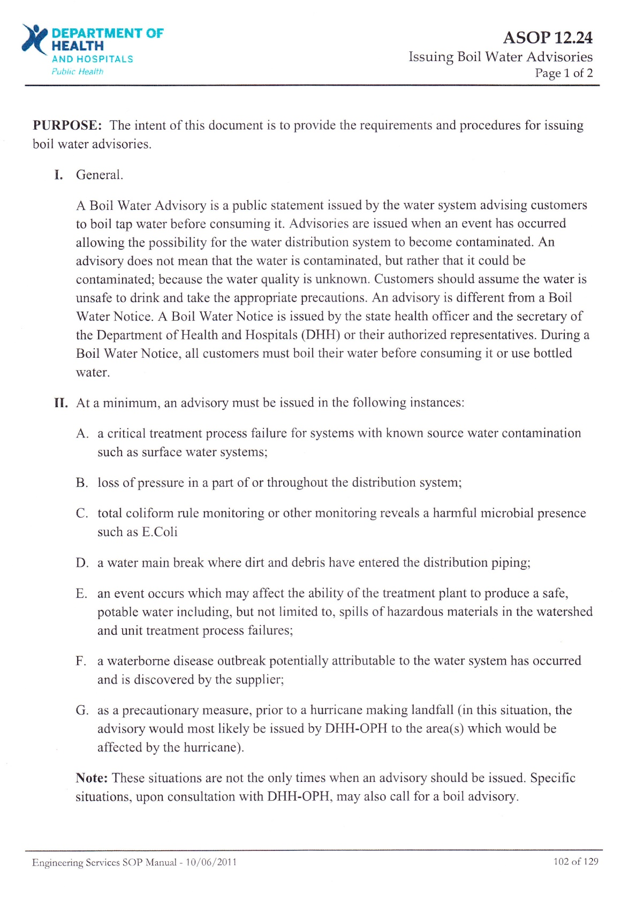
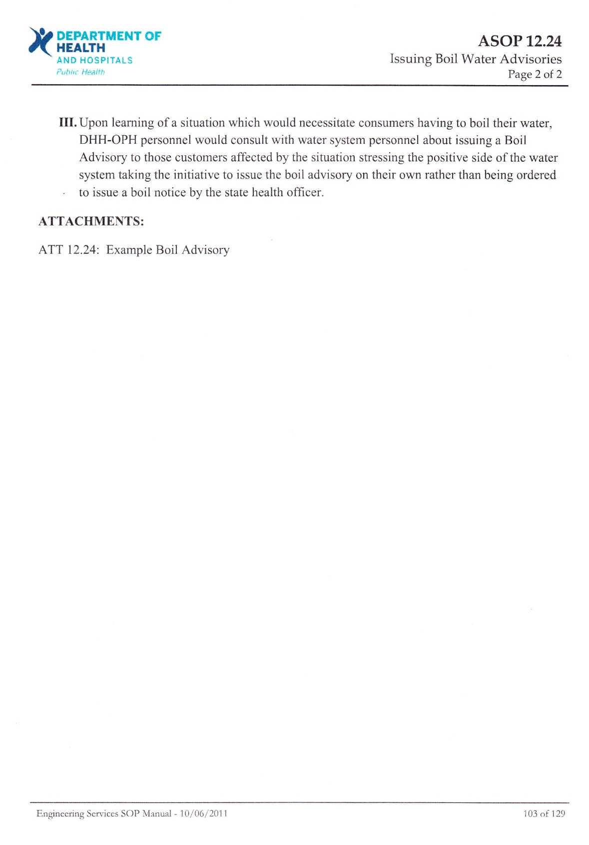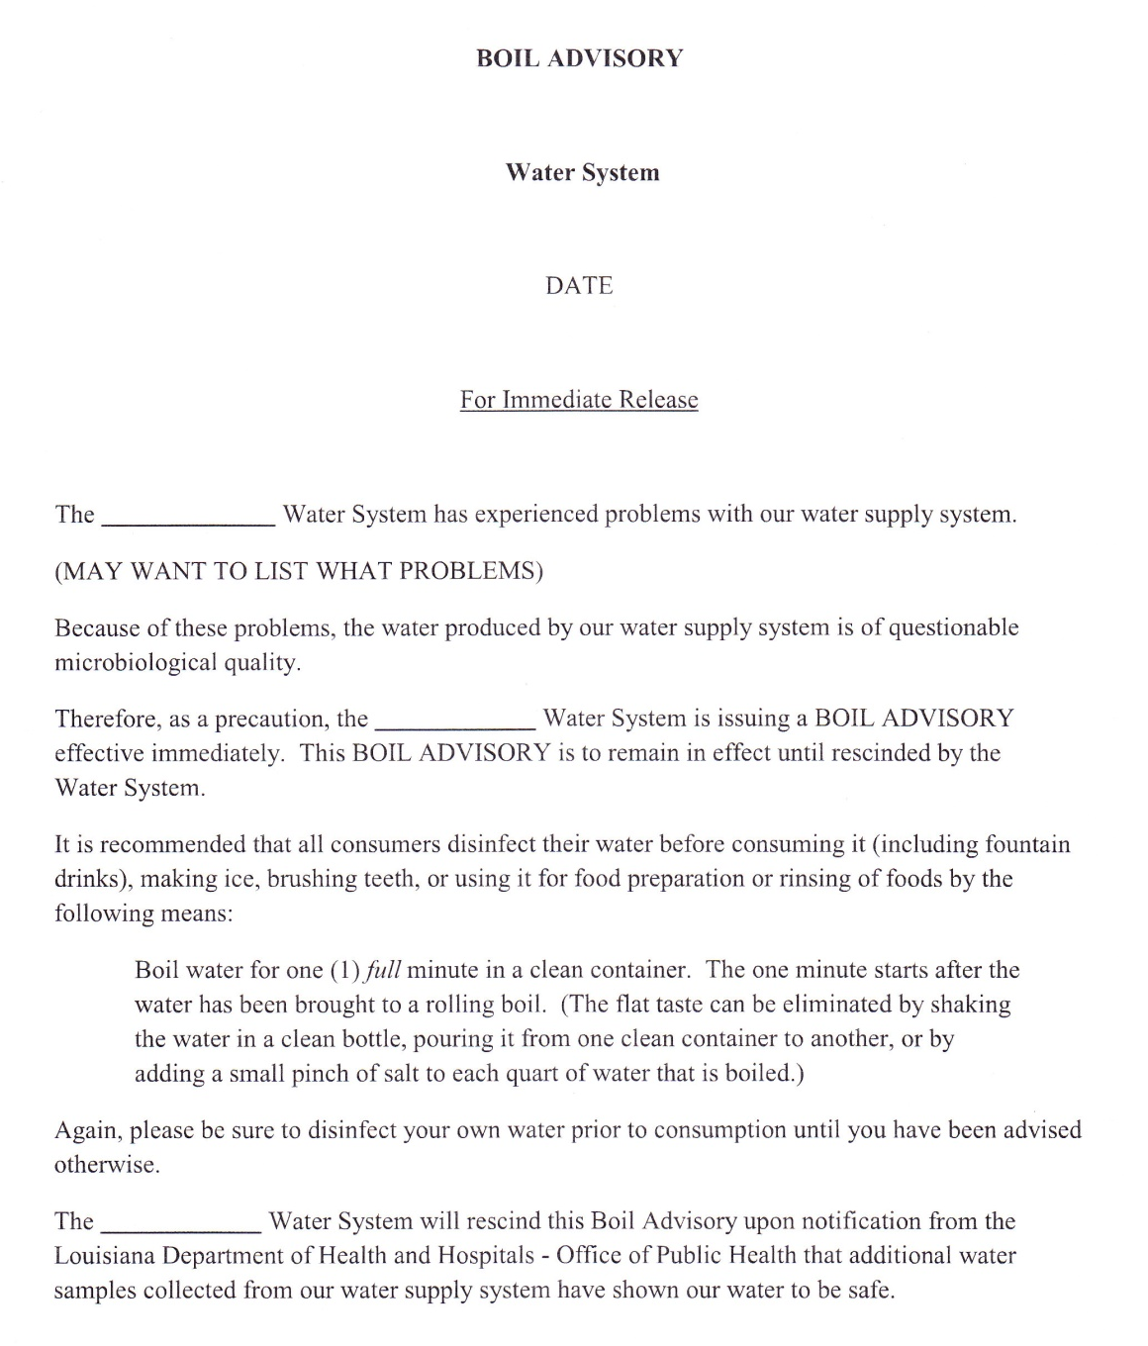

Complete List of DHH Contacts

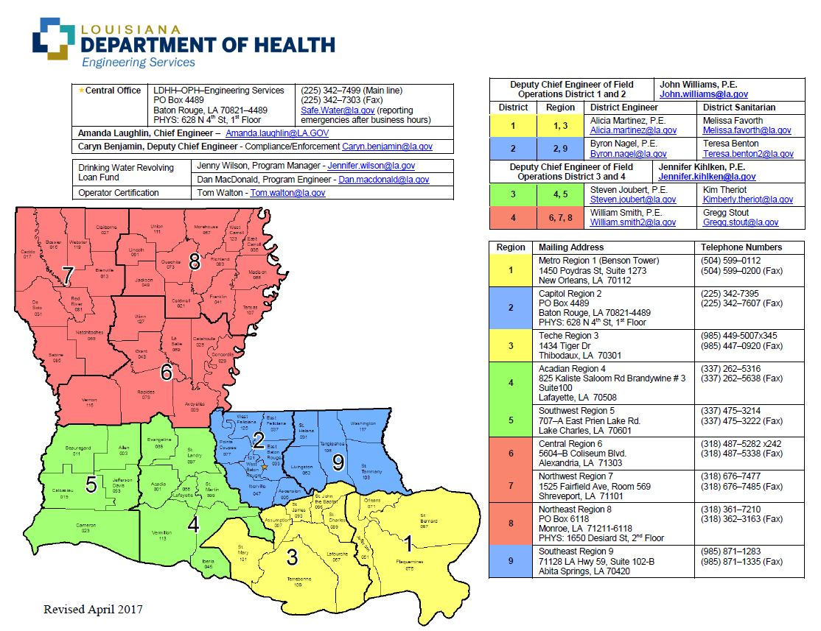

DHH Emergency Bulk Water Hauling Instructions
